Physical Development in Middle Adulthood
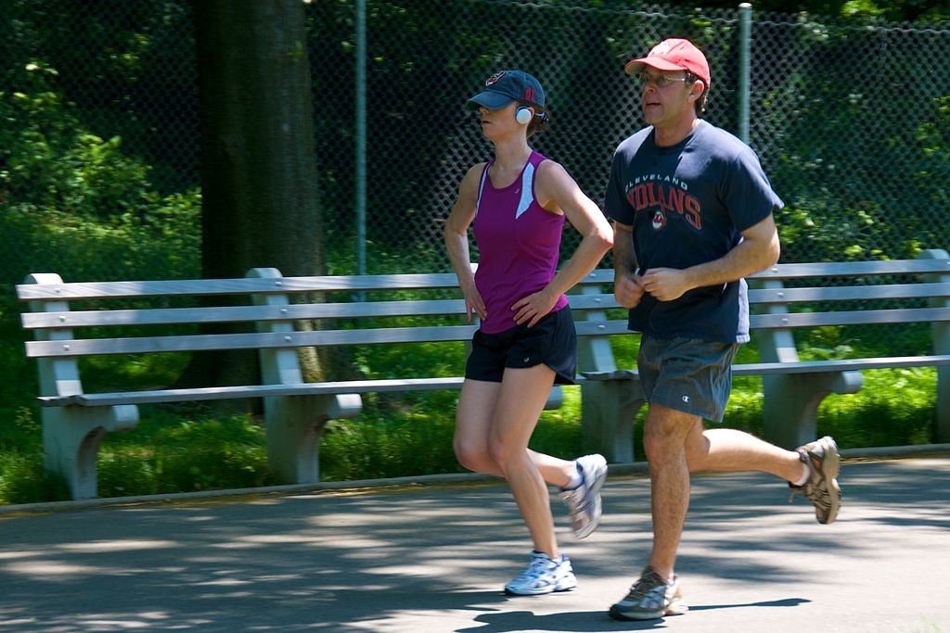There are few biologically based physical changes in midlife other than changes in vision, more joint pain, and weight gain (Lachman, 2004). Vision is affected by age. As we age, the lens of the eye gets larger but the eye loses some of the flexibility required to adjust to visual stimuli. Middle aged adults often have trouble seeing up close as a result. Night vision is also affected as the pupil loses some of its ability to open and close to accommodate drastic changes in light. Autoimmune disease such as rheumatoid arthritis often starts in the 50s. Weight gain, sometimes referred to as the middle-aged spread, or the accumulation of fat in the abdomen is one of the common complaints of midlife adults. Men tend to gain fat on their upper abdomen and back while women tend to gain more fat on their waist and upper arms. Many adults are surprised at this weight gain because their diets have not changed. However, the metabolism slows during midlife by about one-third (Berger, 2005). Consequently, midlife adults have to increase their level of exercise, eat less, and watch their nutrition to maintain their earlier physique.
Hearing loss is experienced by about 14 percent of midlife adults (Gratton & Vasquez in Berk, 2007) as a result of being exposed to high levels of noise. Men may experience some hearing loss by 30 and women by 50. High frequency sounds are the first affected by such hearing loss. This loss accumulates after years of being exposed to intense noise levels. Men are more likely to work in noisy occupations. Hearing loss is also exacerbated by cigarette smoking, high blood pressure, and stroke. Most hearing loss could be prevented by guarding against being exposed to extremely noisy environments. (There is new concern over hearing loss in early adulthood with the widespread use of headphones for IPods and other similar devices.)
Most of the changes that occur in midlife can be easily compensated for (by buying glasses, exercising, and watching what one eats, for example.) And most midlife adults experience general good health. However, the percentage of adults who have a disability increases through midlife; while 7 percent of people in their early 40s have a disability, the rate jumps to 30 percent by the early 60s. This increase is highest among those of lower socioeconomic status (Bumpass and Aquilino, 1995).
What can we conclude from this information? Again, lifestyle has a strong impact on the health status of midlife adults. Smoking tobacco, drinking alcohol, poor diet, stress, physical inactivity, and chronic disease such as diabetes or arthritis reduce overall health. It becomes important for midlife adults to take preventative measures to enhance physical well-being. Those midlife adults who have a strong sense of mastery and control over their lives, who engage in challenging physical and mental activity, who engage in weight bearing exercise, monitor their nutrition, and make use of social resources are most likely to enjoy a plateau of good health through these years (Lachman, 2004).

The Climacteric
One biologically based change that occurs during midlife is the climacteric. During midlife, men may experience a reduction in their ability to reproduce. Women, however, lose their ability to reproduce once they reach menopause.
Menopause for women: Menopause refers to a period of transition in which a woman’s ovaries stop releasing eggs and the level of estrogen and progesterone production decreases. After menopause, a woman’s menstruation ceases (U. S. National Library of Medicine and National Institute of Health [NLM/NIH], 2007).
Changes typically occur between the mid 40s and mid 50s. The median age range for a women to have her last menstrual period is 50-52, but ages vary. A woman may first begin to notice that her periods are more or less frequent than before. These changes in menstruation may last from 1 to 3 years. After a year without menstruation, a woman is considered menopausal and no longer capable of reproduction. (Keep in mind that some women, however, may experience another period even after going for a year without one.) The loss of estrogen also affects vaginal lubrication which diminishes and becomes more watery. The vaginal wall also becomes thinner, and less elastic.
Menopause is not seen as universally distressing (Lachman, 2004). Changes in hormone levels are associated with hot flashes and sweats in some women, but women vary in the extent to which these are experienced. Depression, irritability, and weight gain are not menopausal (Avis, 1999; Rossi, 2004). Depression and mood swings are more common during menopause in women who have prior histories of these conditions rather than those who have not. And the incidence of depression and mood swings is not greater among menopausal women than non-menopausal women.
Cultural influences seem to also play a role in the way menopause is experienced. Numerous international students enrolled in my class have expressed their disbelief when we discuss menopause. For example, after listing the symptoms of menopause, a woman from Kenya or Nigeria might respond, “We do not have this in my country or if we do, it is not a big deal” to which some U. S. students reply, “I want to go there!” Indeed, there are cultural variations in the experience of menopausal symptoms. Hot flashes are experienced by 75 percent of women in Western cultures, but by less than 20 percent of women in Japan (Obermeyer in Berk, 2007).
Women in the United States respond differently to menopause depending upon the expectations they have for themselves and their lives. White, career-oriented women, African-American, and Mexican-American women overall tend to think of menopause as a liberating experience. Nevertheless, there has been a popular tendency to erroneously attribute frustrations and irritations expressed by women of menopausal age to menopause and thereby not take her concerns seriously. Fortunately, many practitioners in the United States today are normalizing rather than pathologizing menopause.
Concerns about the effects of hormone replacement has changed the frequency with which estrogen replacement and hormone replacement therapies have been prescribed for menopausal women. Estrogen replacement therapy was once commonly used to treat menopausal symptoms. But more recently, hormone replacement therapy has been associated with breast cancer, stroke, and the development of blood clots (NLM/NIH, 2007). Most women do not have symptoms severe enough to warrant estrogen or hormone replacement therapy. But if so, they can be treated with lower doses of estrogen and monitored with more frequent breast and pelvic exams. There are also some other ways to reduce symptoms. These include avoiding caffeine and alcohol, eating soy, remaining sexually active, practicing relaxation techniques, and using water-based lubricants during intercourse.
Andropause for men: Do males experience a climacteric? They do not lose their ability to reproduce as they age, although they do tend to produce lower levels of testosterone and fewer sperm. However, men are capable of reproduction throughout life. It is natural for sex drive to diminish slightly as men age, but a lack of sex drive may be a result of extremely low levels of testosterone. About 5 million men experience low levels of testosterone that results in symptoms such as: a loss of interest in sex, loss of body hair, difficulty achieving or maintaining erection, loss of muscle mass, and breast enlargement. Low testosterone levels may be due to glandular disease such as testicular cancer. Testosterone levels can be tested and if they are low, men can be treated with testosterone replacement therapy. This can increase sex drive, muscle mass, and beard growth. However, long term HRT for men can increase the risk of prostate cancer (The Patient Education Institute, 2005).

The Climacteric and Sexuality
Sexuality is an important part of people’s lives at any age. Midlife adults tend to have sex lives that are very similar to that of younger adulthood. And many women feel freer and less inhibited sexually as they age. However, a woman may notice less vaginal lubrication during arousal and men may experience changes in their erections from time to time. This is particularly true for men after age 65. As discussed in the previous paragraph, men who experience consistent problems are likely to have medical conditions (such as diabetes or heart disease) that impact sexual functioning (National Institute on Aging, 2005).
Couples continue to enjoy physical intimacy and may engage in more foreplay, oral sex, and other forms of sexual expression rather than focusing as much on sexual intercourse. Risk of pregnancy continues until a woman has been without menstruation for at least 12 months, however, and couples should continue to use contraception. People continue to be at risk of contracting sexually transmitted infections such as genital herpes, chlamydia, and genital warts. And 10 percent of new cases of AIDS in the United States are of people 50 and older. Practicing safe sex is important at any age. Hopefully, when partners understand how aging affects sexual expression, they will be less likely to misinterpret these changes as a lack of sexual interest or displeasure in the partner and more able to continue to have satisfying and safe sexual relationships.

Exercise, Nutrition, and Health
The impact of exercise: Exercise is a powerful way to combat the changes we associate with aging. Exercise builds muscle, increases metabolism, helps control blood sugar, increases bone density, and relieves stress. Unfortunately, fewer than half of midlife adults exercise and only about 20 percent exercise frequently and strenuously enough to achieve health benefits. Many stop exercising soon after they begin an exercise program-particularly those who are very overweight. The best exercise programs are those that are engaged in regularly-regardless of the activity. But a well-rounded program that is easy to follow includes walking and weight training. Having a safe, enjoyable place to walk can make the difference in whether or not someone walks regularly. Weight lifting and stretching exercises at home can also be part of an effective program. Exercise is particularly helpful in reducing stress in midlife. Walking, jogging, cycling, or swimming can release the tension caused by stressors. And learning relaxation techniques can have healthful benefits. Exercise can be thought of as preventative health care; promoting exercise for the 78 million “baby boomers” may be one of the best ways to reduce health care costs and improve quality of life (Shure & Cahan, 1998).
Nutritional concerns: Aging brings about a reduction in the number of calories a person requires. Many Americans respond to weight gain by dieting. However, eating less does not typically mean eating right and people often suffer vitamin and mineral deficiencies as a result. Very often, physicians will recommend vitamin supplements to their middle aged patients.
The new food pyramid: The ideal diet is one low in fat, sugar, high in fiber, low in sodium, and cholesterol. In 2005, the Food Pyramid, a set of nutritional guidelines established by the U. S. Government was updated to accommodate new information on nutrition and to provide people with guidelines based on age, sex, and activity levels.
The ideal diet is also one low in sodium (less than 2300 mg per day). Sodium causes fluid retention which may in turn exacerbate high blood pressure. The ideal diet is also low in cholesterol (less than 300 mg per day). The ideal diet is also one high in fiber. Fiber is thought to reduce the risk of certain cancers and heart disease. Finally, an ideal diet is low in sugar. Sugar is not only a problem for diabetics; it is also a problem for most people. Sugar satisfies the appetite but provides no protein, vitamins or minerals. It provides empty calories. High starch diets are also a problem because starch is converted to sugar in the body. A 1-2 ounce serving of red wine (or grape juice) can have beneficial effects as well. Red wine can increase “good cholesterol” or HDLs (high density lipoproteins) in the blood and provides antioxidants important to combating aging.

